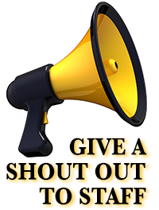
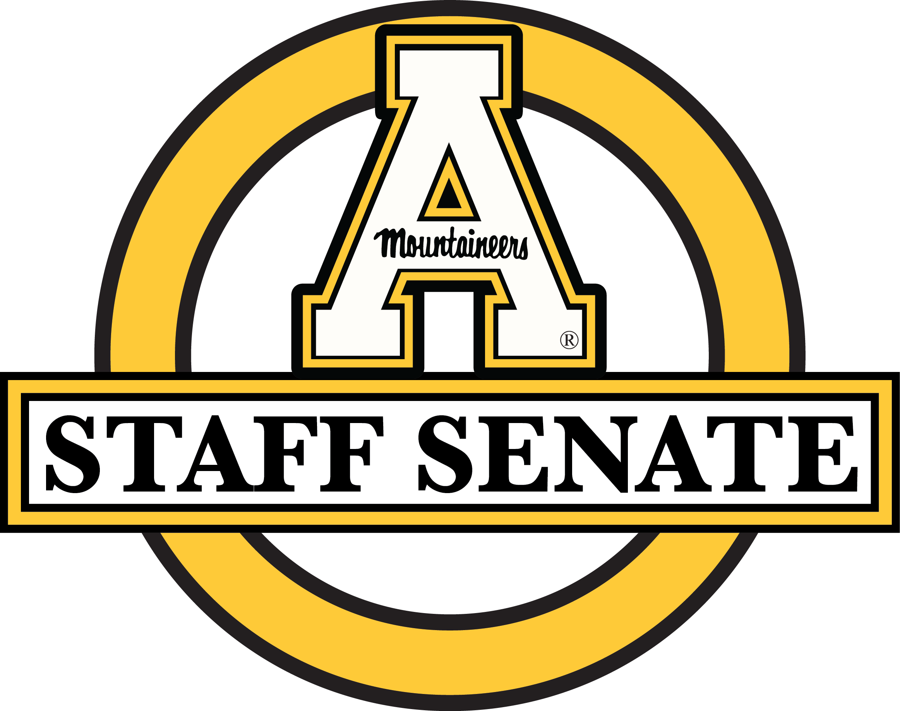
Congratulations to May 2019’s Staff Shout Out Recipients!

Lisa Bare
William Barnes
Amy Beane
Danny Bock
Dennis Bohr
Teresa Bridges
Bruce Bromberger
Craig Butterworth
Sarah-Davis Cagle
Jenny Cancro
June Cannon
Aneisy Cardo
Fred Carrero
Charlie Carroll
Sarah Carter
Robin Chambers
Theresa Claybrook
Ernie Coley
Heather Colvard
Jeff Cook
Brandy Cornett
Laney Crumbley
Melissa Daniel
Kim Dastell
Charles Davis
Lauren Davis
Cindy Day
Kevin Delgado-Valentin
Mike Dicker
Selena Dollar
Darrel Farrow
Alice Fisher
Brenda Fletcher
Samantha Fuentes
Dala Gant
Bob Gibbard
Arthur Gilreath
Michelle Gimlin
Eric Gormly
Paul Grant
Bill Greene
Jason Grubb
Emily Haas
Judy Haas
Margaret Hardin
Monica Harless
Kara Harmon
Joe Helton
James Hicks
Matt Huntanar
Sharon Jensen
Tom Kane
Sam Keenan
Anna Kimbro
Deborah Kirksey
Ron Kisiah
Meredith Kitson
Stephanie Lee
Anna Lee Evans
Sonya Long
Thomas Main
Shayla Marcum
Chad McCrary
Chris Miller
Charity Miller
Karl Moretz
Chad Morgan
Kim Morton
Michael O'Hara
Vanessa Painter
Kelly Palmer
Marissa Pannell
Grace Pitts
Brent Pope
Hannah Pope
Amy Price
Stephanie Ramsey
Shane Reece
Jenna Reed
Jane Rex
Robert Schaffer
Linda Scherry
Lacy Schmidt
Cathy Scott
Patrick Setzer
Nicole Shomaker
Astrid Sosa
Will Streater
Vicki Theis
Kato Thompson
Chris Trew
Brittany Upton
Santiago Villarreal
Sarah Warriner
Robin Waters
Beth Watts
Nate Weigl
Daniel West
Kelli Wilson
Andrea Winkler
Angel Worley

